React Lab Report - CricketApp

# Introduction

This lab focuses on applying ES6 features such as map, arrow functions, destructuring, and merging arrays within a React application.

# Objectives and What I Learned

- Use map() method to display player details

- Apply arrow functions to filter players

- Destructure arrays into teams

- Merge arrays using the spread operator

- Use a flag to conditionally render components

# Hands-on Practice Summary

Built 'cricketapp' using create-react-app. Two components - ListofPlayers and IndianPlayers - are conditionally rendered based on a flag. The app demonstrates core ES6 features inside a React component.

# Code Snippets

**App.js**

import React from 'react';  
import ListofPlayers from './components/ListofPlayers';  
import IndianPlayers from './components/IndianPlayers';  
  
function App() {  
 const flag = true;  
 return (  
 <div className="App">  
 <h1>🏏 Cricket App</h1>  
 {flag ? <ListofPlayers /> : <IndianPlayers />}  
 </div>  
 );  
}  
export default App;

**ListofPlayers.js**

import React from 'react';  
const ListofPlayers = () => {  
 const players = [...];  
 const filtered = players.filter(p => p.score < 70);  
 return (  
 <div>  
 <h2>All Players</h2>  
 <ul>{players.map((p, i) => <li key={i}>{p.name} - {p.score}</li>)}</ul>  
 <h2>Filtered Players</h2>  
 <ul>{filtered.map((p, i) => <li key={i}>{p.name} - {p.score}</li>)}</ul>  
 </div>  
 );  
};  
export default ListofPlayers;

**IndianPlayers.js**

import React from 'react';  
const IndianPlayers = () => {  
 const T20players = [...];  
 const RanjiPlayers = [...];  
 const allPlayers = [...T20players, ...RanjiPlayers];  
 const oddTeam = allPlayers.filter((_, i) => i % 2 === 1);  
 const evenTeam = allPlayers.filter((_, i) => i % 2 === 0);  
 return (  
 <div>  
 <h2>Odd Team</h2>  
 <ul>{oddTeam.map((p, i) => <li key={i}>{p}</li>)}</ul>  
 <h2>Even Team</h2>  
 <ul>{evenTeam.map((p, i) => <li key={i}>{p}</li>)}</ul>  
 </div>  
 );  
};  
export default IndianPlayers;

# Screenshot

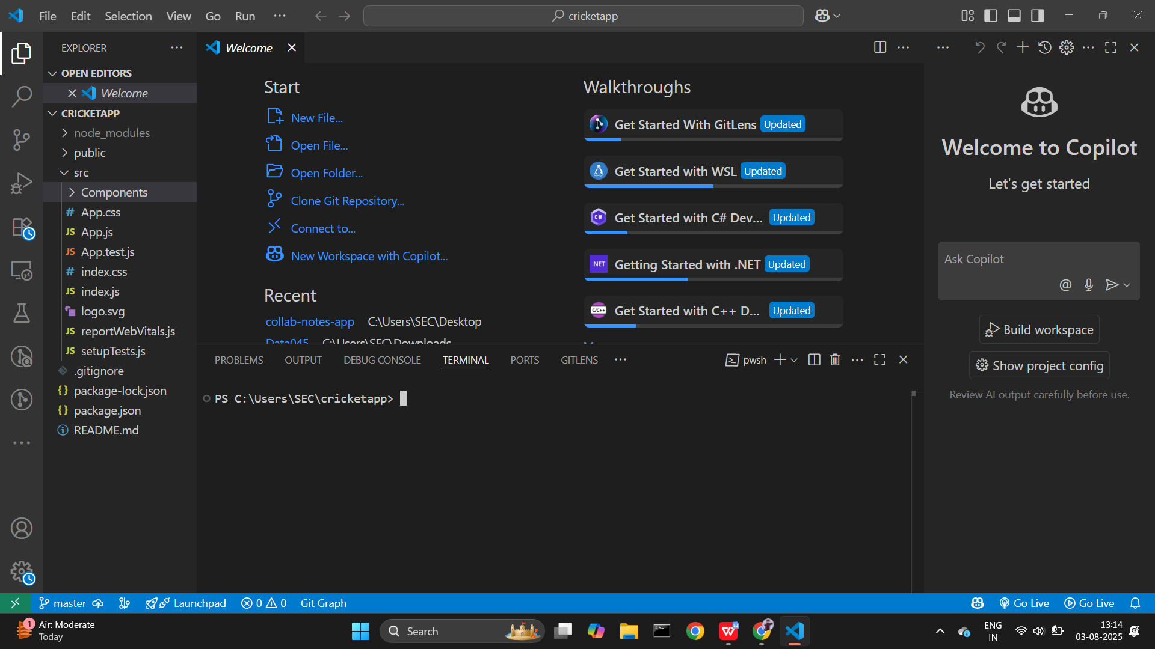

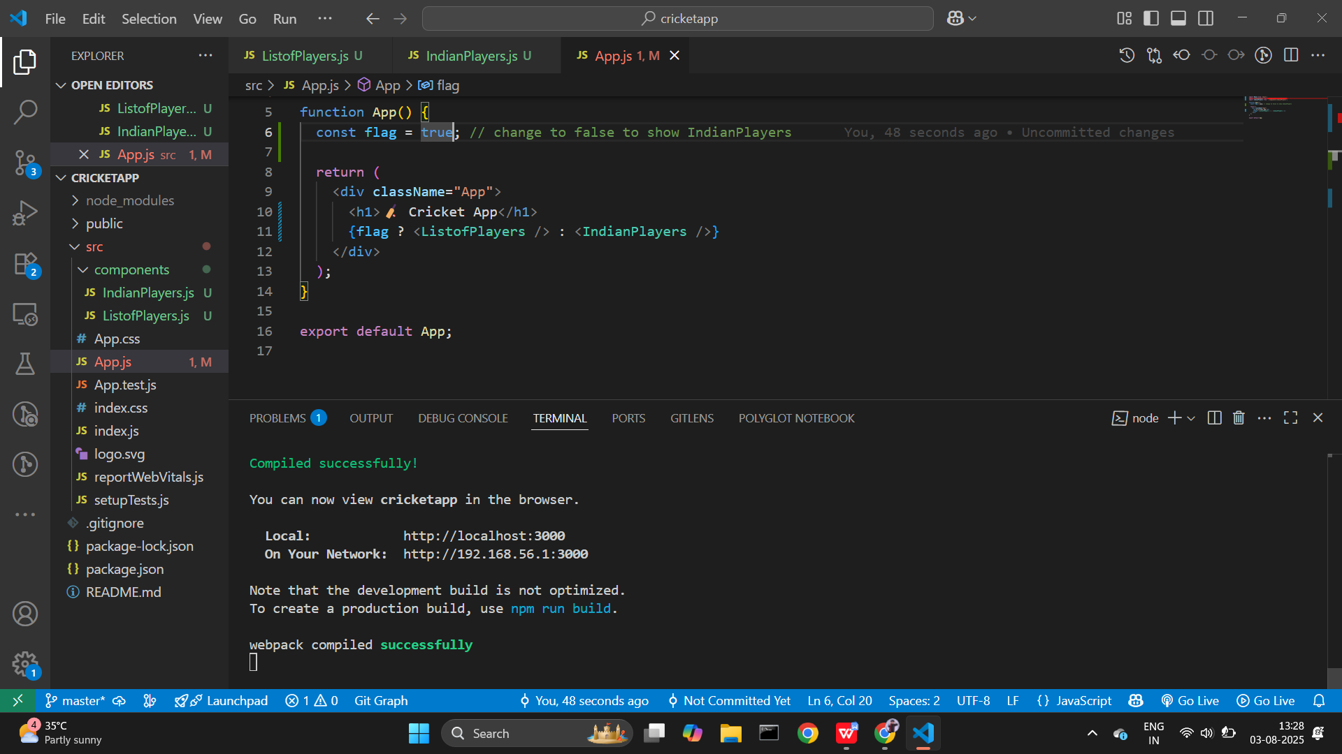

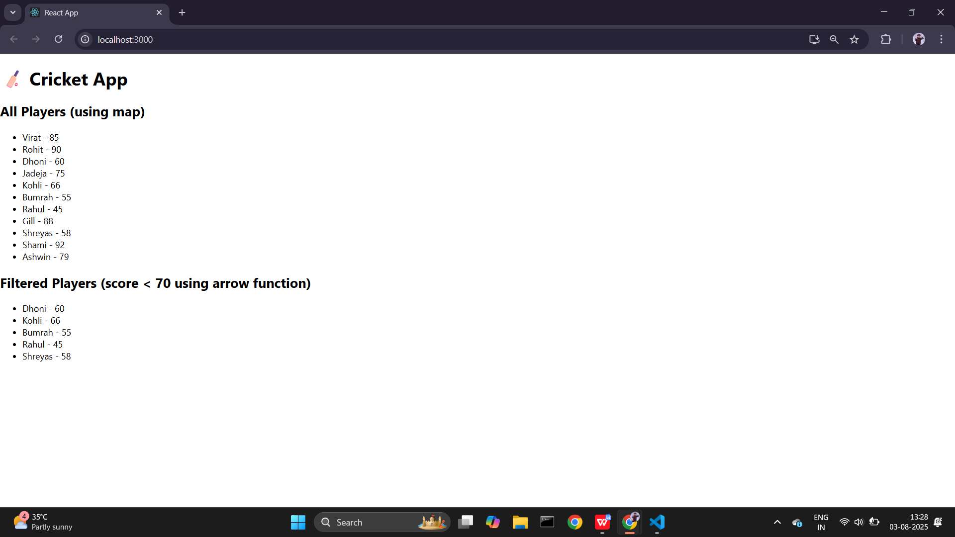

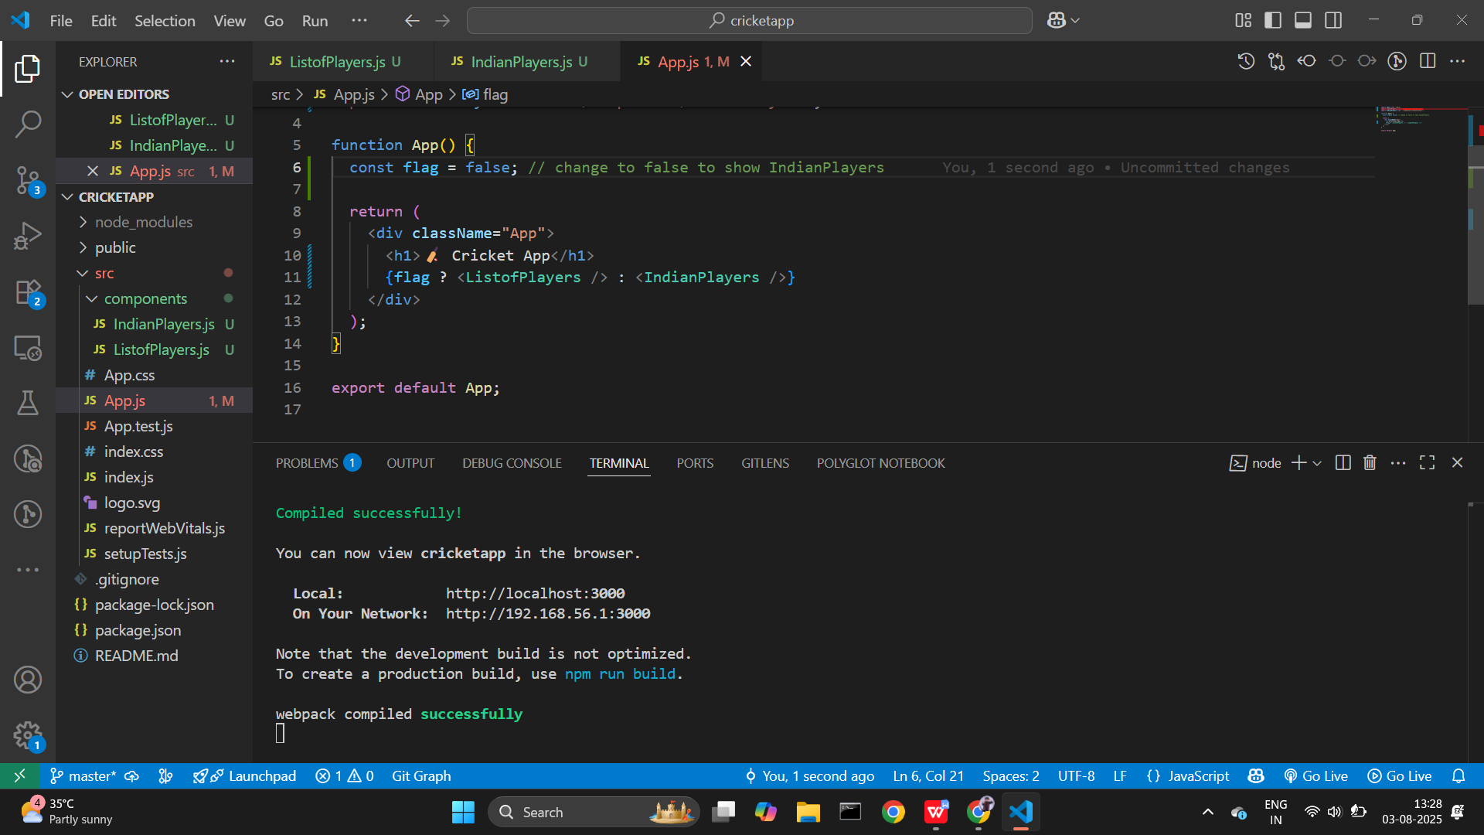

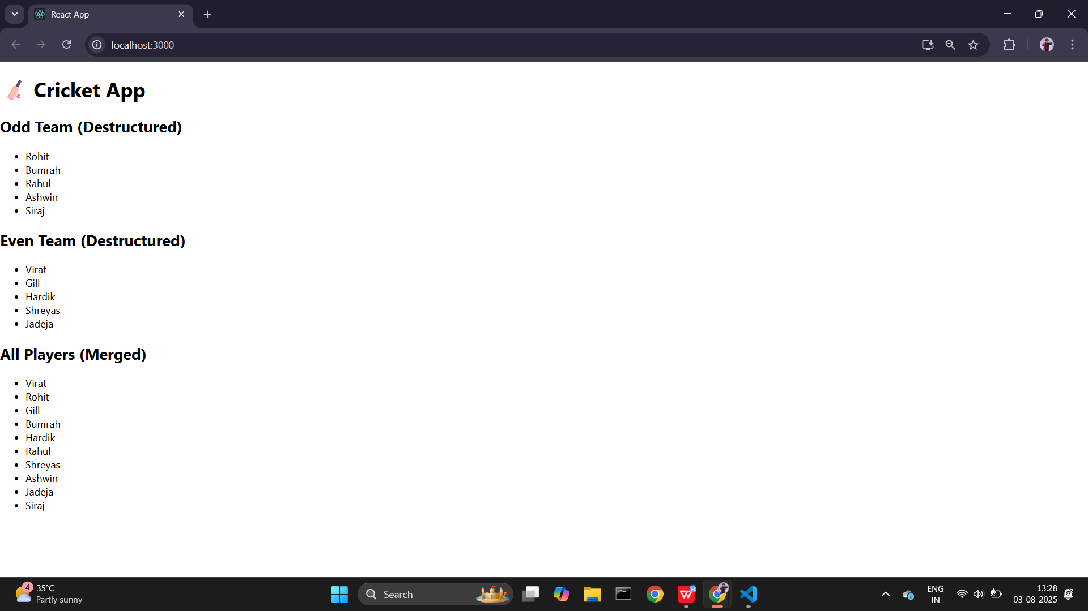

# Conclusion

This lab helped reinforce ES6 concepts and how to integrate them into React apps for cleaner, modular code.